Program Structures and Algorithms

Spring 2023(SEC – 03)

NAME: Changyu Wu

NUID: 002111594

**Task: Assignment 4 (WQUPC)**

**Relationship Conclusion:**

Approximately, m = 4n

**Evidence to support that conclusion:**

Based on the charts, I think the relationship between m and n might be linear, because both two charts show us straight lines. Therefore, I calculate average results of m/n.

In order to reduce the uncertainty brought by randomly generated pairs (m), I calculate average result of each m also.

**Graphical Representation:**

I did several experiments, including the following two charts.

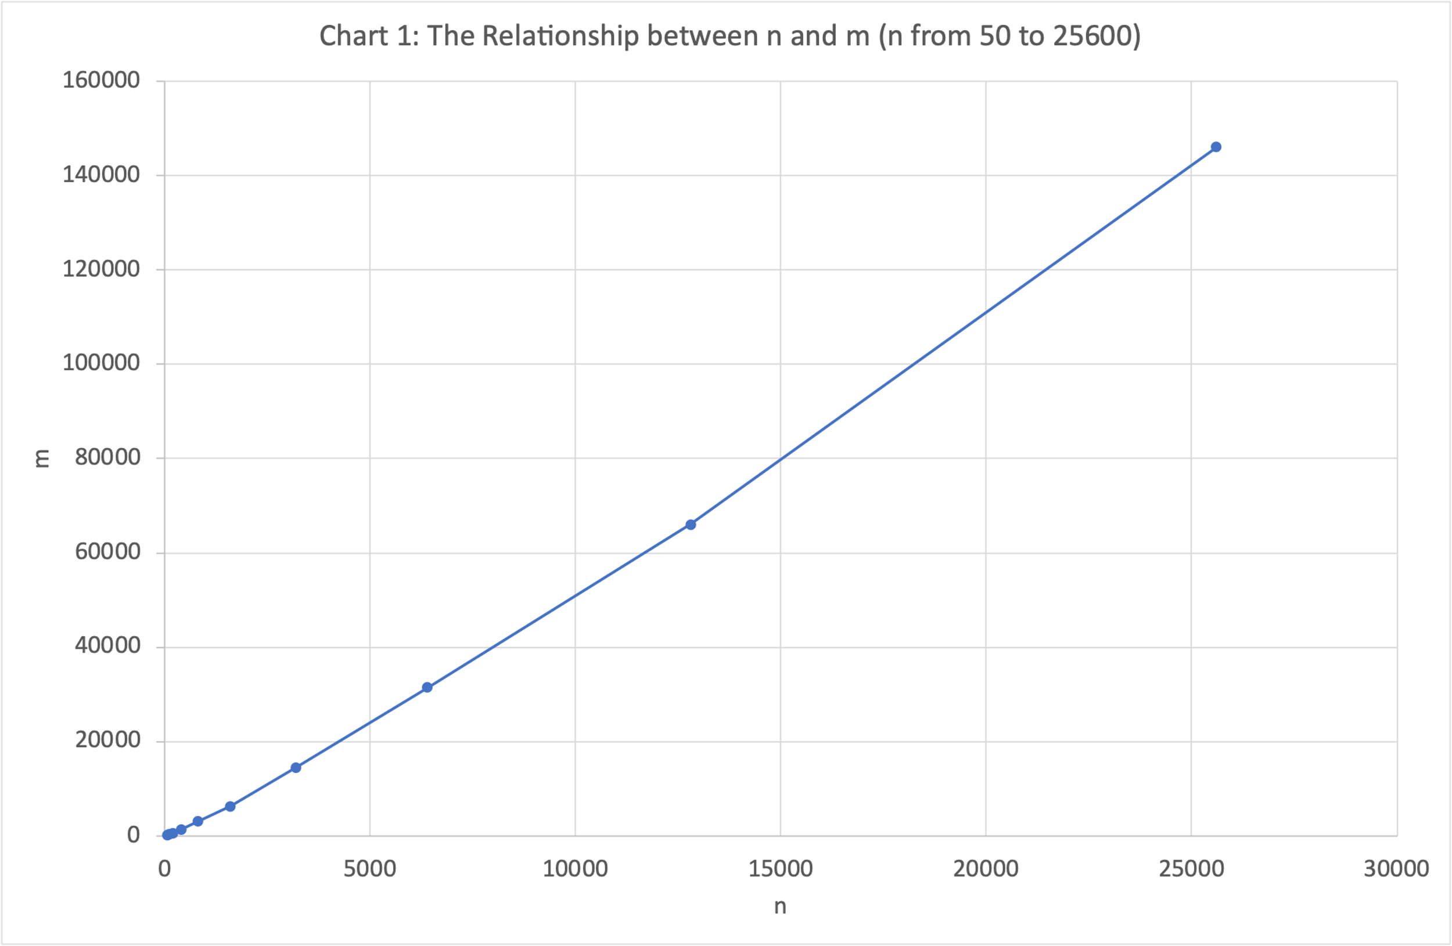

Chart 1: n from 50 to 25600

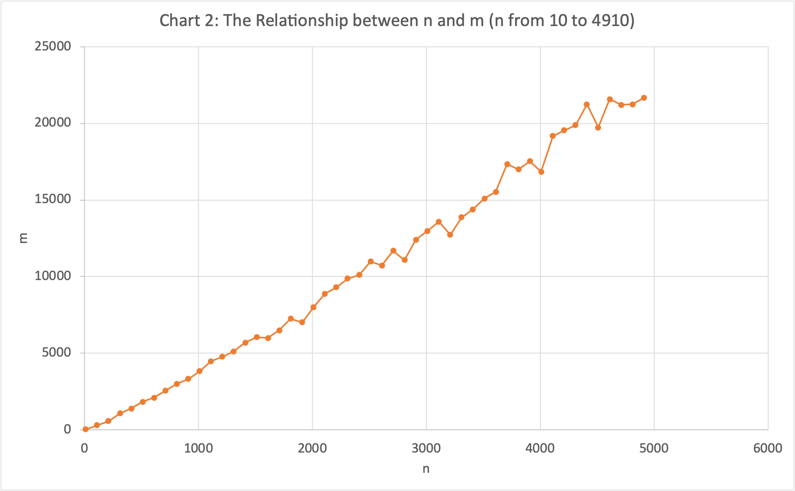

Chart 2: n from 10 to 4910, step by 100

**Unit Test Screenshots:**

Step 1:

Step 2 & 3:

